Vermot-Desroches Matthias

Rapport de séance n°11

During this session, I tried to assemble the frame we received last time.

Since the bus driver were on strike, I worked at home and could not ask help with the professors when I encountered problems, but I will write them and ask for answers during the next session.

After listing all the pieces we had, I realized that some springs that were present on the cover of the frame were missing.

Then, I decided to take a look at the nuts and screws. I realized that the nuts had something like rubber inside them and I could not make the screws fit because of it.

Here is a picture:

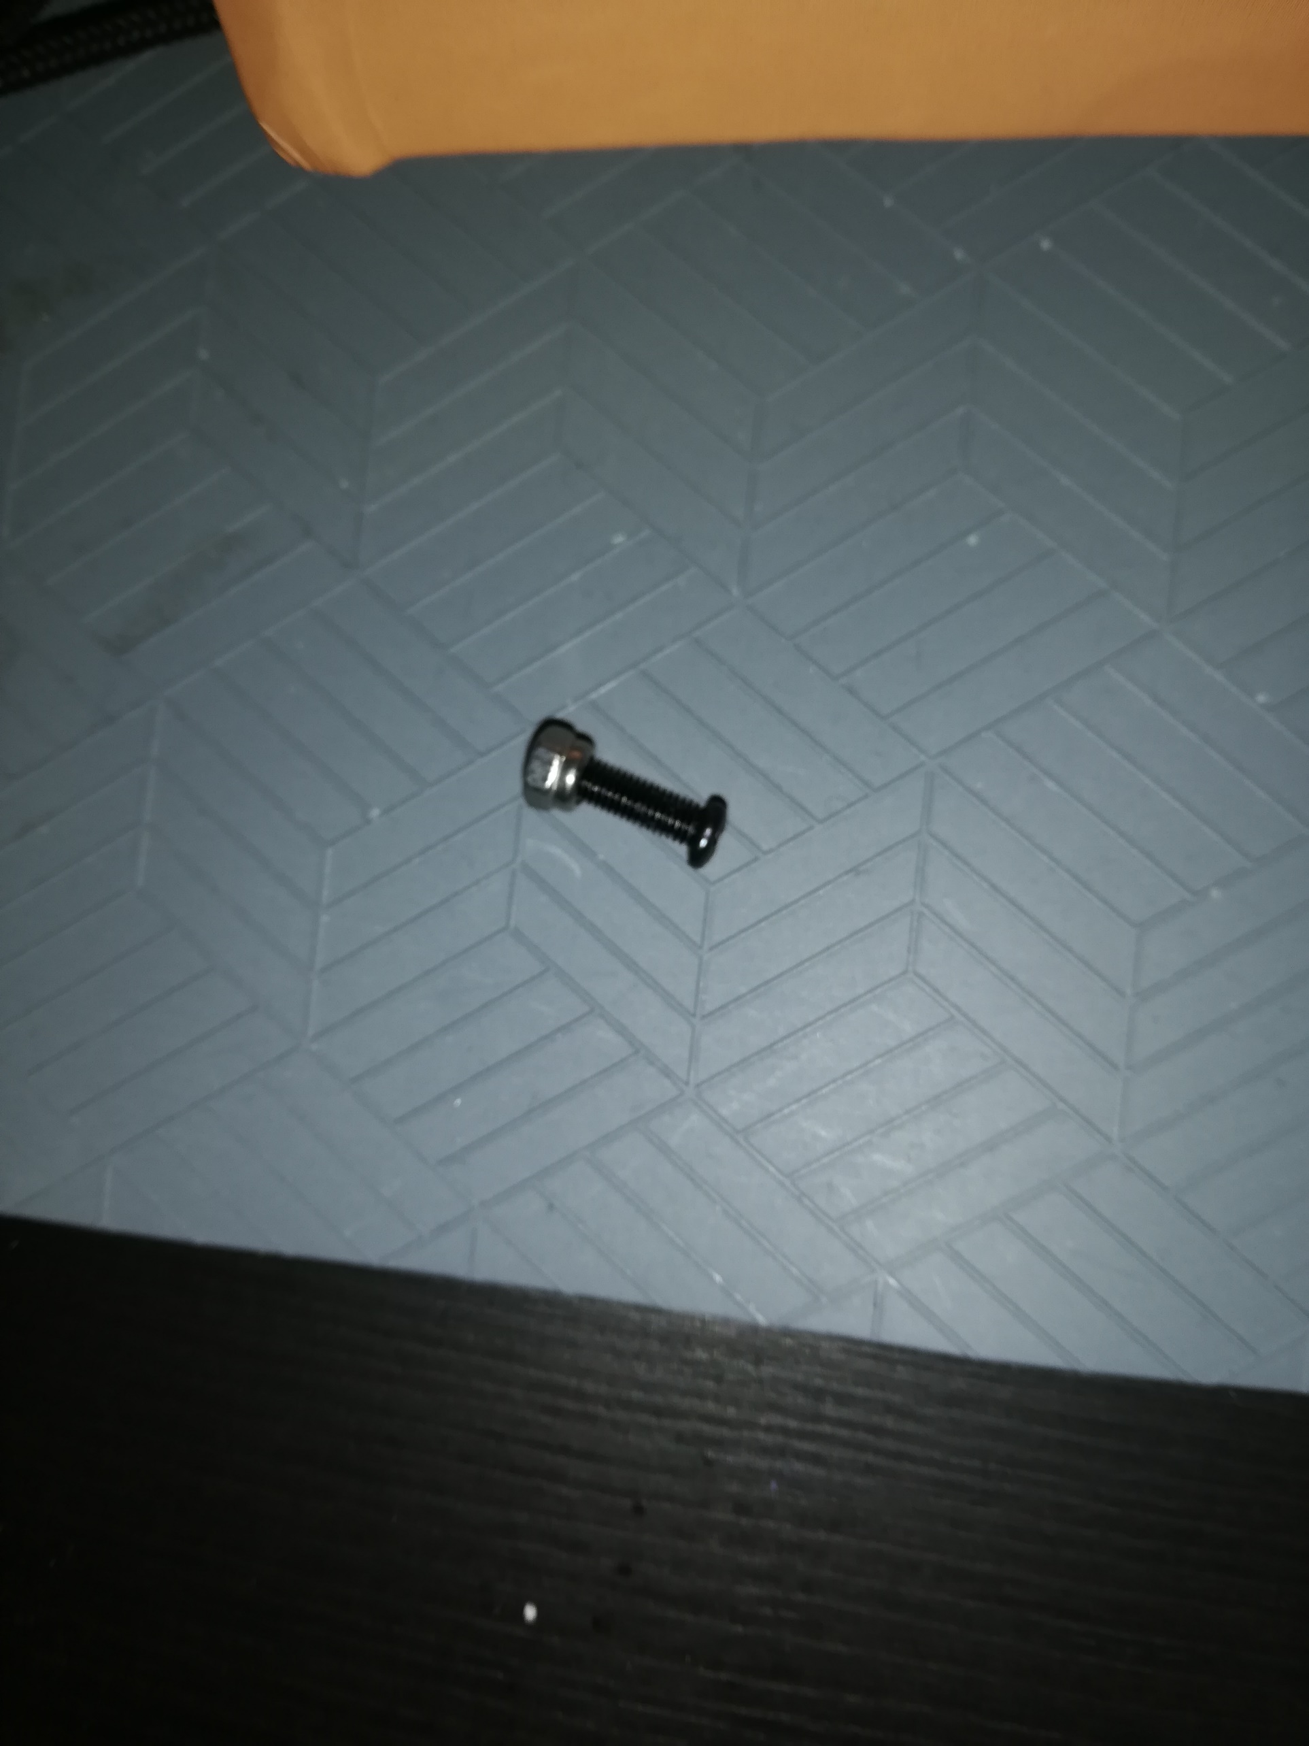

You can see that the screw is blocked at the beginning of the nut. The nut do not even allow to make the screw stand right, it is always bended even with the help of tools.

After that, I tried to put the nut in reverse just to see if it worked. And it worked a little:

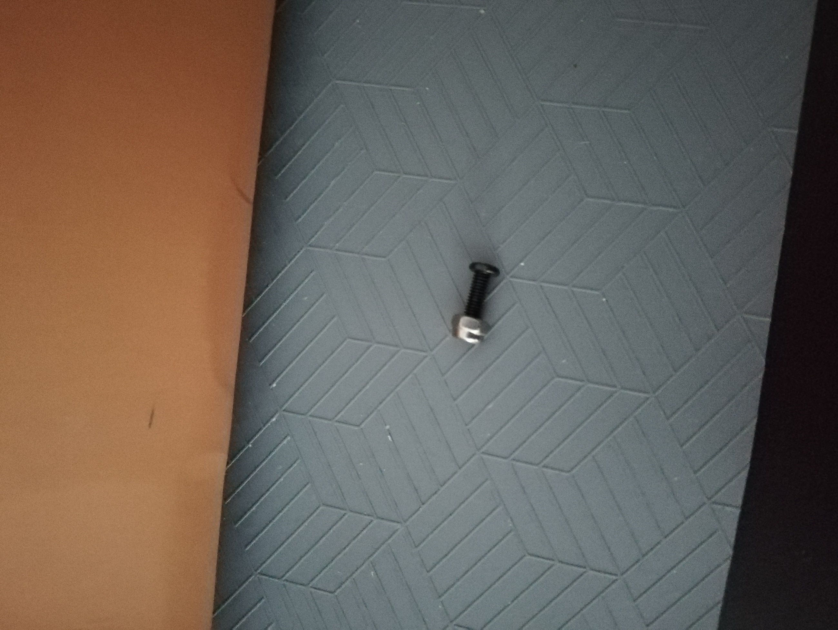

Here, you can see that I could screw the nut a little bit before it was stopped by the rubber part inside the nut.

This took up many time before I decided to move on to another task, as in my opinion if the nuts did not fit, I would have a lot of trouble to continue to assemble.

After that, I wanted to see how the wheel ensemble and suspension would be fixated on the frame.

Here is a picture of how they look and how it is meant to be with the suspensions:

I discovered that the support pieces for the suspension were too large to be fixated. Here is a picture:

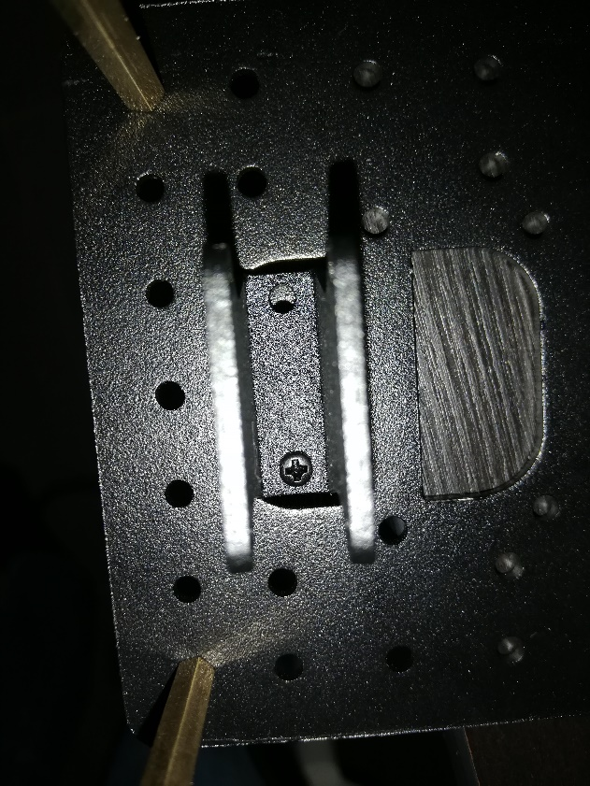

Here, you can see that we can’t use a second screw to fix the piece on the frame, so we can’t fix the piece at all. We will maybe need to make our own piece.

Then, I started to make the wheel ensemble. Here is how they look independently:

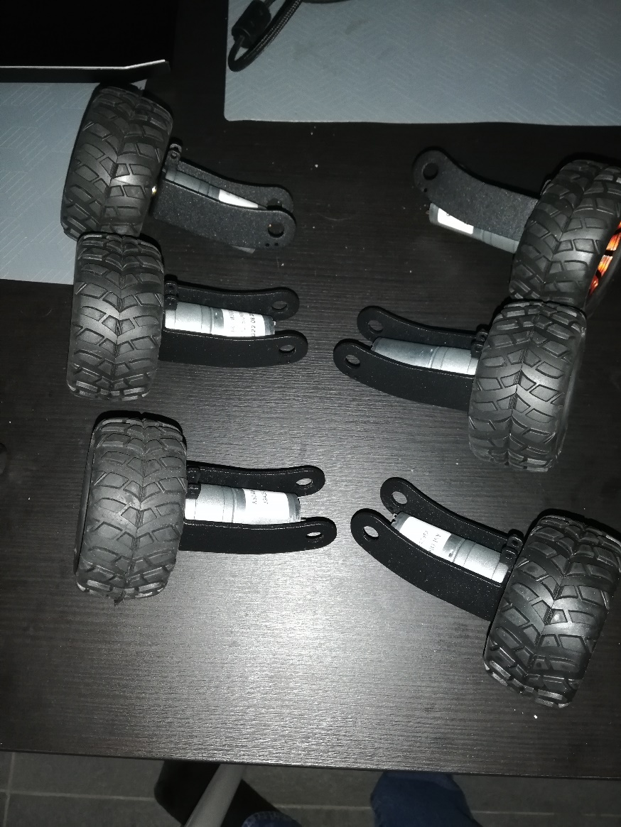

And here is how they look when linked with a support piece:

I struggled a lot to make them, as I did not know which pieces needed to be fixated first. So I assembled and unassembled the ensemble a lot of time before finishing it.

However, after finishing the first ensemble, I hesitated to continue as the nuts could not guarantee its fixation. Here is a picture to explain my point:

You can see that there are big mechanical functional game (rough translation of “jeu” in a mechanical ensemble), meaning the ensemble is not stable and could collapse in function.

After trying many things to reduce this “game”, I decided to keep things like that for now and ask for help during the next session. So, I finished all the other ensemble, here is a picture of all of them:

I stopped the assemble at this step, as I did not want to redo everything after getting my answers during the next session.